
AL-KUNOOZE SCIENTIFIC JOURNAL
Vol.11 No. 1 (2025)
ISSN 2706-6231 (ONLINE)
ISSN 2706-6223 (PRINT)

Title: Time New Roman Bold, 14pt, Capitalized Headed
Name: Bold 12pt
Department and university (italic) 12pt
Corresponding Author Email Address: sinantkkkjjjjag2016@uomosul.edu.iq
ORCID ID: https://orcid.org/0000-00$$$01-8374-5240
DOI: https://doi.org/10.23975/bjvr.2024.153kkk278.1137
Received: 6 September 2024 ; Accepted: 9 October 2024.
All manuscript typed with Time New Roman 12pt
Leave 2cm from both sides

Abstract 12pt (100- 300 words)

This research paper examines strength and resistance in female characters in Anthony Doerr’s ‘All the Light We Cannot See’. This study reveals the themes of women’s independence and perseverance as depicted in the novel through a feminist lens. It focuses on the lives of female characters such as Marie-Laure LeBlanc and Madame Manec, as well as their agency and ability to recover from misfortune in a patriarchal and violent world. This study examines the experiences of female characters such as Marie-Laure LeBlanc and Madame Manec in order to highlight the different ways in which women challenge gender norms and assert their power as they are portrayed in the book. It does this by analyzing their behaviors, relationships, and social roles.

1

Introduction

Women were portrayed in World War II in Anthony Doerr’s novel “All the Light We Cannot See,” and their role was rich and multifaceted. The novel does not explicitly focus on feminist issues, but it greatly highlights the independence, strength, and resilience of the female characters. By examining the characters of Marie-Laure and Madame Manec through a feminist lens, we can view their strength, their challenge to societal norms, and their contribution to shaping their destinies amid the turmoil of war. Miss Marie-Laure is a strong and central character who embodies courage and resilience despite her blindness. She challenges the restrictions imposed by her disability. Likewise, Madame Manek’s participation in the resistance emphasizes women’s active participation in important historical events, transcending traditional gender roles. Ultimately, All the Light We Cannot See celebrates the diverse roles and accomplishments of women during a turbulent period in history, challenges gender stereotypes, and showcases their remarkable contributions to the war effort.

In her thesis, "The Impact of World War II on Women’s Labor Force Participation," Claudia Coldth examines how the war affected women’s participation in the labour force and emphasises how it sparked social and economic change. Based on retroactive surveys conducted in 1944 and 1951, Coldth’s research shows that although women’s employment rose as a result of the war, its direct impact on raising women’s incomes in 1950 was less significant than first thought. In spite of this, women’s employment and labour market involvement remained relatively stable during the chaotic 1940s, suggesting that the war had a major indirect effect on women’s employment [1].

Methodology

Give detailed referenced method used at the study.

Results
Tables with details as follows;

Table (1): The liver enzymes (ALT and AST) in the blood serum of different groups

Time  Parameters | Groups | At 7 a.m. | At 12 a.m. | At 12 p.m. | LSD
ALT  (IU/l) | T1(Male) | 00±0.36  Bb | 025.8±0.35  Ab | 029.5±0.63  Ab | 02.2
ALT  (IU/l) | T2(Female) | 09.7±0.53  Ca | 03.3±1.1  Aa | 030.9±0.44  Ba | 02.2
AST  (IU/l) | T1(Male) | 00.1±0.47  Cb | 07.8±0.36  Aa | 040.5±0.29  Ba | 01.25
AST  (IU/l) | T2(Female) | 03.8±0.19  Aa | 04.8±0.14  Cb | 030.6±0.45  Bb | 01.25
Mean ± SE, Number of sheep (n=5).

Figures with details included in text
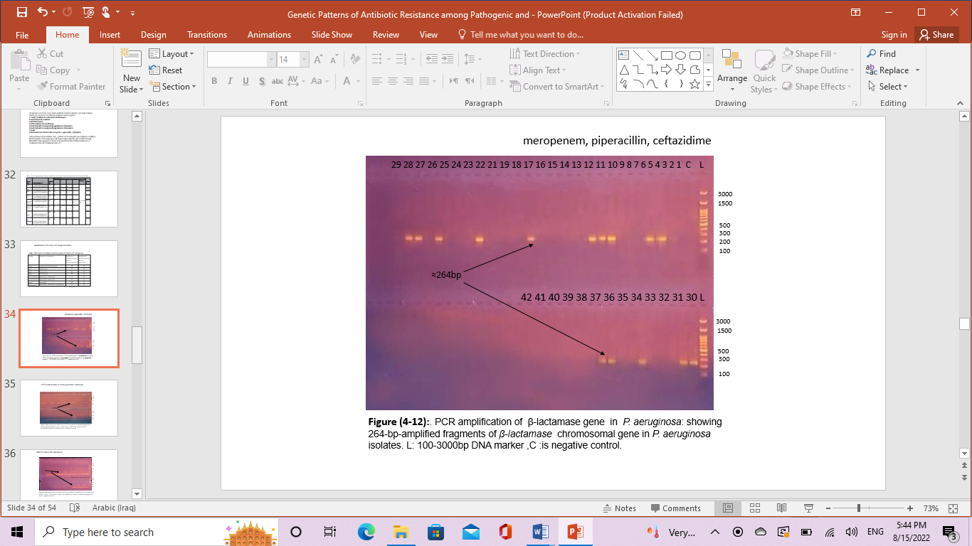
Figure (1): PCR amplification of xxxxxx gene in P. oooosa: showing 264-bp-amplified fragments of β-lactamase chromosomal gene in Pooooooo isolates. L: 100-3000bp DNA marker,C :is negative control

Discussion: Discuss the results separately in this section.
Conclusion:
Conflict of interest:

References
References should be numbered in text as [1]; [1,3,8]; [1-4, 6,9]
References listed serially at the end of the manuscript following Vancouver style.

- Coldth C. The role of World War II in the rise of women’s work. J Econ Perspect. 1993;7(3):97-112.
- Goldin C, Olivetti C. Shocking labor supply: A reassessment of the role of World War II on US women’s labor supply. Am Econ Rev. 1999;89(4):873-897.
- Tickner JA. Feminist perspectives on international relations. Brown J World Aff.
- 1996;3(1):61-79.
- Herdianti M. Marie-Laure’s struggle as a blind teenager in Anthony Doerr’s All the light we cannot see. Lit Rev. 2018;20(2):45-62.
- Doerr A. All the light we cannot see. Scribner; 2014.

- Hossain MM. Cognitive and linguistic manifestations of a blind child in Anthony Doerr’s All the Light We Cannot See. Lingua Cultura. 2023;17(1):93-100.

